I WILL BE A GAME DESIGNER – EL FUTURO CON WILL
Ya estudiamos algunos verbos modales para hablar de obligaciones, prohibiciones, sugerencias y habilidad y posibilidad (must, mustn’t, should, shouldn’t, can y can’t).
Ahora vamos a estudiar un nuevo verbo modal que sirve para hablar del futuro. Este nuevo verbo modal es WILL, y también tiene que estar seguido de un verbo principal para tener sentido.
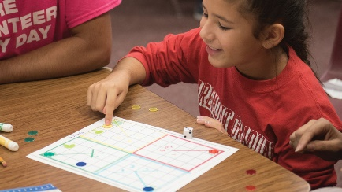
1. Cuando will acompaña a un verbo le da la forma futura. Veamos dos ejemplos:
will +be = seré, serás, será, seremos, serán
will + work = trabajaré, trabajarás, trabajará, trabajaremos, trabajarán
I will be a game designer. I will work for Nintendo
Como los demás verbos modales, will conserva la misma forma para todas las personas:
I will, you will, he will, she will, it will, we will, they will
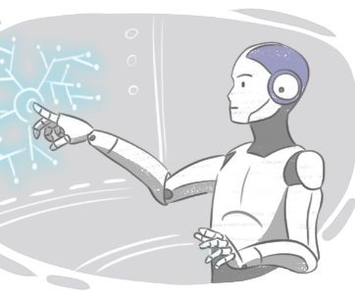
y va acompañado del verbo principal en infinitivo:
I / You / He / She / It / We / They will + infinitive
I will study English with Chat GPT or BARD.
It will rain tomorrow.
They will live in Italy in 10 years’ time.
We will learn with robot teachers.
2. WILL también tiene una forma contraída: ‘ll que es la que se usa más comúnmente
I | ’ll | be | a game designer
You | ’ll | be | a game designer
He | ’ll | be | a game designer
She | ’ll | be | a game designer
It | ’ll | be | a great job.
We | ’ll | be | game designers
they | ’ll | be | game designers
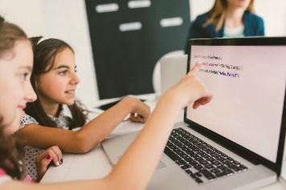

3. Al igual que los otros modales, will forma el negativo con la partícula not. El negativo will not también tiene su forma contraída, won’t:
I | will not / won’t | be | a sound artist
You | will not / won’t | be | a sound artist
He | will not / won’t | be | a sound artist
She | will not / won’t | be | a sound artist
It | will not / won’t | be | a nice job
We | will not / won’t | be | sound artists
They | will not / won’t | be | sound artists

4. Para hacer preguntas yes/no, will se ubica al principio de la oración, seguido del sujeto y el verbo principal:
Will | I | work | in the USA? | Yes, I will / No, I won’t
Will | you | work | in the USA? | Yes, you will / No, you won’t
Will | he | work | in the USA? | Yes, he will / No, he won’t
Will | she | work | in the USA? | Yes, she will / No, she won’t
Will | it | work | faster | Yes, it will / No, it won’t
Will | we | work | in the USA? | Yes, we will / No, we won’t
Will | they | work | in the USA? | Yes, they will / No, they won’t

Where | will | I | work? | I will work in the USA
Where | will | you | work? | You will work in the USA
Where | will | he | work? | He will work in the USA
Where | will | she | work? | She will work in the USA
How | will | it | Work? | It will work faster.
Where | will | we | work? | We will work in the USA
Where | will | they | work? | You will work in the USA
5. Para hacer preguntas Wh, se ubuca la WH al principio de la oración, seguida de will, seguido del sujeto y el verbo principal:

6. Will se usa generalmente para:

A. expresar una decisión espontánea, tomada en el momento en que se está hablando, es decir para una decisión tomada en ese mismo instante. Veamos estos ejemplos:
a) A: Tomorrow’s cyber-Monday!
B: That’s great! I’ll buy new trainers!

b) The computer is running slow. I’ll clean it with C cleaner.

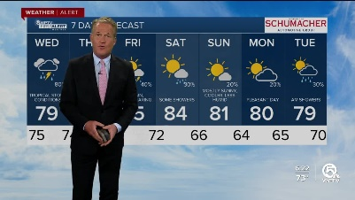
B. predecir lo que sucederá en el futuro:
a) Futurologists predict that many homes will have robots in the future.
b) Children won’t go to school; they’ll have a robot teacher who teaches them at home.

d) It will rain tomorrow.

PRÁCTICA

1. Leé el texto y decí si los enunciados de más abajo son verdaderos o falsos. Si son falsos, corregilos:

Life in the Future

I think life will be very different in twenty years’ time. People won’t go to school or universities, they’ll study and learn at home with the help of a robot teacher. Also, homes will be smart and appliances will communicate with each other and with you. Your stove, for instance, will tell you when your food is ready to eat. Future RFID chips will store information about all the items in your cabinets. When you need more food, your cabinets will tell you to buy it.

RFID: is “radio-frequency identifcation.”

- I think life won’t be different in twenty years’ time.
- People will learn at school and universities.
- Homes will be smart.
- Home appliances will communicate with you but they won’t communicate with each other.
- Your stove will tell you when your food is ready.
- Cabinets will have RFID chips.
- Your food will tell you when you need to buy more.

2. What do you think? Write sentences with will to make predictions about the future.

a. people - drive normal cars / flying cars
b. robots – do the household jobs / not do the household jobs
c. people – live on the moon / on Mars
d. we - download information on our computers / into our heads
e. your microwave - talk to you / not talk to you.
f. people – speak only English / three or four languages.

3. Escuchá el diálogo entre Sarah y Peter (el audio está en el aula virtual, debajo de este apunte):
A. Listen and mark true (T), false (F) or doesn’t say. (DS)
What do they think will happen in the future?
- Cars won’t fly. …………
- People will study at school. …………
- People will live on the Moon. …………
- We won't have many diseases. …………
- Doctors will visit you in your home. …………
- We will have robots to cook and clean the house. …………
B. Correct the false sentences.
4. Ahora leé el diálogo y verificá tus respuestas en el ejercicio anterior:
Sarah: What do you think the future will be like?
Peter: I think cars will fly.
Sarah: Really? What do you think the school will be like?
Peter: I think people will study in their houses via the Internet.
Sarah: What will hospitals be like?
Peter: I think medicine will be totally different. We won’t have many of the diseases that we have today.
Sarah: How will houses be different?
Peter: May be we’ll have robots that clean our house and cook.
Sara: That will be nice.

Cuando hablamos de cómo creemos que serán las cosas en el futuro generalmente usamos la expresión I THINK que quiere decir CREO QUE o PIENSO QUE, seguida de una oración con WILL.

I think cars will fly.
I think people will study in their houses via the Internet.

También es común emplear la palabra PROBABLY, que quiere decir probablemente y se ubica entre WILL
y el VERBO PRINCIPAL.

We will PROBABLY download information into our heads.
People will PROBALY speak three or four languages.

1. What do you think life will be like in 20 years’ time? Write sentences using I THINK or PROBABLY and the ideas below. Escribí oraciones usando I THINK o PROBABLY y las ideas de abajo.
EJEMPLO:
Artificial intelligence – transform society
I THINK artificial intelligence will transform society.
Artificial intelligence will PROBABLY change society.

- People – live in other planets
- Computers – talk to their users
- I – be a successful programmer
- My screen reader – read many languages perfectly well.
- Programmers - have lots of work.

Las predicciones con will no necesariamente tienen que referirse a un futuro lejano, tampoco tienen que ser siempre afirmativas:
It WILL rain TOMORROW.
The English exam WON’T be difficult.
WILL Microsoft offer open source software?

2. Complete the sentences with WILL or WON’T
a. Houses…be smart
b. Robots…govern the world.
c. People… have robot teachers.
d. I… have a big computer shop.
f. My best friend… be a psychologist.
g. I… develop software for hospitals.
h. My teachers…work in Canada next year.
i. I… design RFID chips for kitchen cabinets.

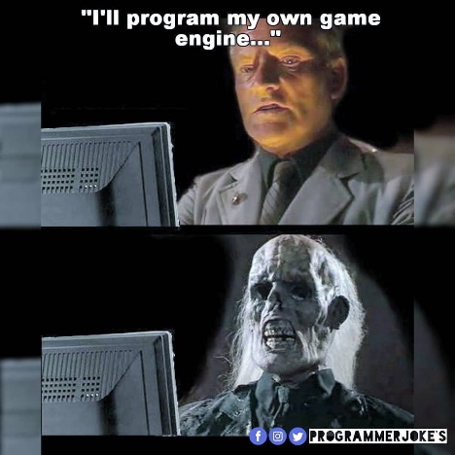
3. Make predictions or ask about the future. Use the questions as a guide.
a. Who will win the next Boca-River match?
b. Who will be the next president in Argentina?
c. How much will a standard laptop cost in 2022?
d.) Will you pass all your exams this year?
e. What subjects will you study next year?
f. What will you do in 5 years’ time? (work for a big programming company/ have my own business/be a teacher/ be a successful programmer

