Erythromycin Production
1. Introduction
Mountaineer Biocorp, Inc., was contacted by Capstone Chemical Company Life Science Division to investigate and produce a pharmaceutical product in August 2011. Phase 1 involved investigation of about 100 different pharmaceuticals and they were ranked based on the information available on: synthesis, reaction kinetics, and thermodynamic properties. Phase 2 concentrated on defining the processes for eight drugs from Phase 1: metformin hydrochloride, metoprolol, diphenhydramine, gluconic acid, insulin, erythromycin, penicillin G, and acetylsalicylic acid. After further research, metformin hydrochloride, metoprolol, and diphenhydramine were dropped from consideration. Lactic acid was found to have sufficient information for more detailed research and was added to the list of candidates, resulting in six pharmaceuticals being presented at the end of Phase 2.
Erythromycin was the pharmaceutical of choice for the design of a manufacturing plant. Erythromycin is a macrolide antiobiotic, which slows and sometimes kills gram-positive bacteria by reducing the production of important proteins needed by the bacteria to survive. Figure 1 shows the chemical structure of erythromycin.
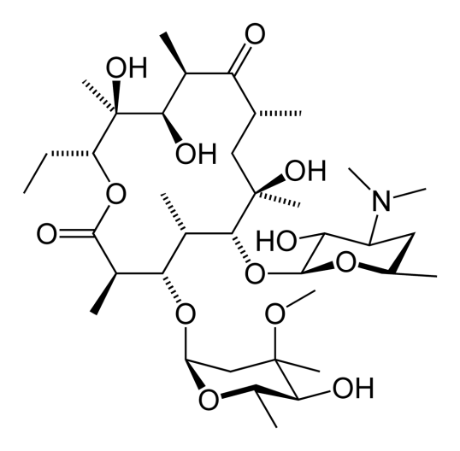
Figure 1: Chemical Structure of Erythromycin [Wikipedia]
Research in Phase 3 focused on creating a coherent plant design based on the information found for reaction kinetics, product separation, and purification. Scheduling and economics were also evaluated in this phase.

2. Results

None of the five optimized cases had a positive net present value (NPV) after ten years of operation. Table 1 shows the specifications of Cases 1-5 and the NPV after ten years of operation. Case 2 had the highest NPV due to being able to purchase smaller equipment compared to Cases 1 and 3. Cases 4 and 5 required extra operators, due to the overlap of the operation of some equipment, which increased the cost even though the equipment was slightly less expensive.
Table 1: Economic Summary for Cases 1-5
Case | Fermenters in Parallel | Number of Batches per year | NPV ($million)
Case 1 | 2 | 194 | -8.93
Case 2 | 3 | 288 | -8.36
Case 3 | 1 | 103 | -12.17
Case 4 | 4 | 385 | -11.94
Case 5 | 5 | 482 | -11.44

In order to try and obtain a positive NPV, the economic factors were manipulated by changing FCI_{L}, C_{OL}, and C_{UT}, C_{WT}, and C_{RM} factors. Table 2 shows the resulting NPV and values of factors previously mentioned. The factors were reduced to their lowest typical value [Turton et al., 2009] for estimating manufacturing cost.

Table 2: NPV Comparison Using Smallest Multiplication Factors for Estimating Manufacturing Cost
NPV ($million) | FCI_{L} Factor | C_{OL} Factor | Factor for C_{UT}, C_{WT}, and C_{RM}
-8.36 | 0.180 | 2.76 | 1.23
-7.28 | 0.180 | 1.92 | 1.23
-6.30 | 0.180 | 1.92 | 1.00
-5.44 | 0.149 | 1.92 | 1.00

If this process was being implemented at a plant that already had all of the equipment, then the fixed capital investment (FCI) would be zero and the resulting NPV would be $1.72 million after 10 years of operation. This analysis assumes that the utility and labor costs would remain the same. The factors used for estimating the manufacturing cost for this NPV were the same as in the first row, NPV of -$8.36 million, in Table 2. If this process was run with other fermentation processes, the use of the downstream processing equipment would increase, resulting in better utilization of the equipment. By pairing the processing equipment with multiple fermentation processes, the cost could be shared to purchase and maintain the equipment, resulting in savings for the all of the processes sharing the equipment.
The major costs associated with plant design can be seen in Table 3. This table shows the equipment bare module cost and the operating labor for each design case. Utility and raw material costs were constant throughout the cases with values of $149,000/y and $1.1 million/y, respectively. For Cases 1-3, three operators/shift was the average needed, while Cases 4 and 5 had increased labor costs due to the overlap of equipment. The total number of operators required was 13 for Cases 1-3, 16 for Case 4, and 17 for Case 5. All equipment costs were calculated using Capcost, unless otherwise specified.

Table 3: Equipment Bare Module and Operating Labor Costs
Costs | Case 1 | Case 2 | Case 3 | Case 4 | Case 5
Equipment ($million) | 6.7 | 6.3 | 9.2 | 6.3 | 6.0
Operating Labor ($thousand/y) | 650 | 650 | 650 | 800 | 850

Process Description
Figure 2 shows the process flow diagram for the batch erythromycin plant. The batch starts with sterilization followed by pumping deionized water into the fermenter, R-701. The water is heated to 30°C by heater, E-702. Then glucose and sodium nitrate, the main nutrients for erythromycin production, are dissolved in the water by the agitator in R-701.
The solution is then inoculated aseptically using spores of Streptomyces erythreus from a seed tank, and the cells are allowed to grow using the nutrients and air supplied. The inlet air is added to fermenter, R-701, using a compressor, C-701, at a rate of 0.4 volume air/minute/volume broth [Bunch]. The air is filtered and sterilized by a small air filter, F-701, to prevent other microorganisms from entering the fermentation process. As the compression of the air causes the temperature to rise, the air is cooled using cooling water in E-701.

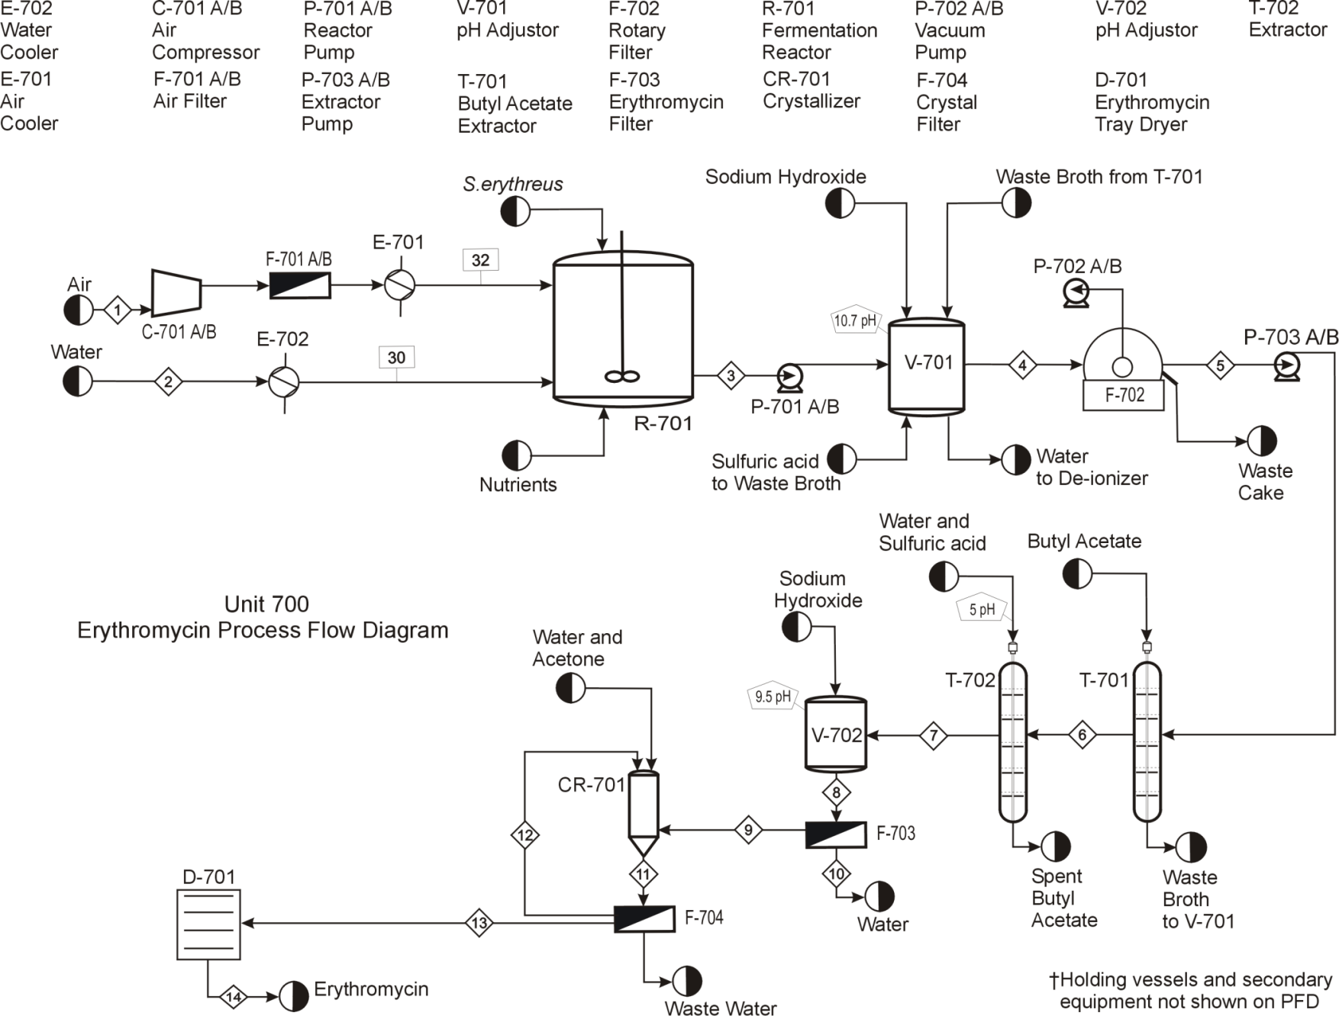
Figure 2: PFD for the Preliminary Process Design for Erythromycin
After the 72 h fermentation period, the contents are pumped by P-701 into V-701, where the pH is adjusted from 7.5 to 10.7 by adding NaOH. The solid cell components of this mixture are then filtered from the broth in a rotary vacuum drum filter, F-702. The erythromycin is then extracted from the broth using butyl acetate in T-701 and is subsequently re-extracted from the butyl acetate to water (pH of 5) in T-702. The butyl acetate is recovered and recycled from T-702 to T-701; the waste broth from T-701 is recycled back to V-701 where the pH of the water is lowered from 10.7 to 7.0. Note that V-701 is first used to adjust the pH of the fermentation broth from 7.5 to 10.7, as stated above. Then it is cleaned and reused to lower the pH of the T-701 waste broth from 10.7 to 7.5. After the pH of the waste broth is adjusted, it is sterilized and deionized and recycled back to R-701.
The erythromycin-rich water is then sent to V-702, where it is mixed, using a static mixer, with a sodium hydroxide solution to adjust the pH of the mixture to 9.5, thereby decreasing the solubility of erythromycin in the solution. The solution is allowed to stand, and erythromycin crystals are formed and fall to the bottom of V-702. The crystals are separated using a filter, F-703, and excess water is removed and treated using a UV sterilizer and recycled back to the deionizer.
The rough erythromycin crystals enter the crystallizer, CR-701, where they are mixed with acetone. Water is added to the crystallizer at a specific rate before the addition of hydroxypropyl methyl cellulose (HPMC) seed crystals. Upon the addition of the seed crystal, water is continually added to CR-701 until acetone solvate crystals form. The solvate crystals from CR-701 are filtered in F-704, washed with water, and returned to CR-701. In the crystallizer, the solvate crystals are mixed with water and transformation into erythromycin dihydrate occurs. The dihydrate crystals are filtered again in F-704 and then dried in D-701, a vacuum tray dryer.
Figure 3 shows the processing steps in a Gantt chart for the recommended case. The first shift has the most work to process the erythromycin and, therefore, requires the most operators, (4/shift). Demand for operators decreases after the first processing shift, as can be seen by the decrease in equipment being used. The second shift and third shifts require 3 and 2 operators, respectively.
Figure 3: Gantt Chart for Recommended Case

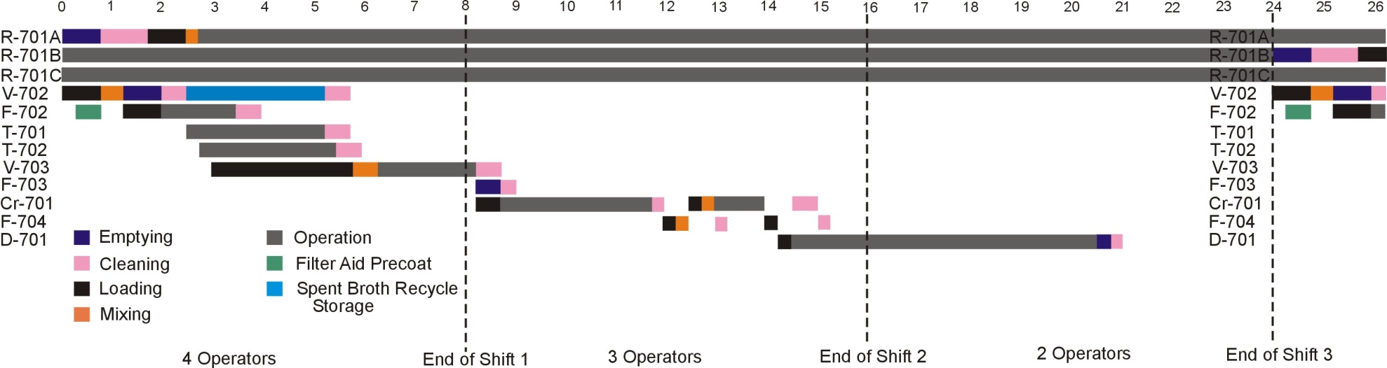

3. References (includes ones not cited here, but cited in complete report)

Aworanti, O., Agarry, S., Arinkoola, A., Adeniyi, “Mathematical Modeling for the Conversion of Animal Waste to Methane in Batch Bio-reactor.” Internation Journal of Engineering Science and Technology (IJEST), 3, 573-581, (2011). 19 Feb 2012. <http://www.ijest.info/docs/IJEST11-03-01-192.pdf>.

Baier, G. “Liquid-Liquid Extraction Based on a New Flow Pattern: Two-Fluid Taylor Couette Flow.” University of Wisconsin—Madison. (Dissertation) 1999. Pg 25 <http://grahamgroup.che.wisc.edu/pub/baier_thesis.pdf >.

Beckmann, Wolfgang. “Seeding the Desired Polymorph: Background, Possibilities, Limitations, and Case Studies.” Organic Process Research & Development. 4, 372-383 (2000)

Benitez, J. Principles and Modern Applications of Mass Transfer Operations. John Wiley & Sons: 2009 p 464.

Bunch, R.L., et. al “Erythromycin, its Salts, and Method of Preparation.” Patent 2,653,899. April 14, 1953.

Bushell, M. E., Smith, J., Lynch, H.C., “A physiological model for the control of erythromycin production in batch and cyclic fed batch culture.” Microbiology, 143, 475-480 (1997).

Certified Lye. High-Quality Sodium Hydroxide (NaOH) and Potassium Hydroxide (KOH) for Making Soap. “Lye (Sodium Hydroxide) and Caustic Potash (Potassium Hydroxide) Quality, Sizes, Prices, & Shipping.” April 4, 2012. <http://www.certified-lye.com/>

Dickenson, Christopher. Filters and Filtration Handbook 4th Ed. Cambridge, UK. . Elsevier Science Ltd. 1997. Elsevier Advanced Technology.

Dubal, G. “Podbielniak Contactor: A Unique Liquid-Liquid Extractor.” Pharmaceutical Online. 2000. <http://www.pharmaceuticalonline.com/article.mvc/Podbielniak-Contactor-A-Unique-Liquid-Liquid-0003>.

Filter Aid Filtration. General Filtration. 10 Apr. 2012.
<http://www.generalfiltration.com/assets/uploads/Filter_Aid_Filtration.pdf>.

General Filtration. General Filtration. 10 Apr. 2012.
<http://www.generalfiltration.com/Products/3>.

Grainger Products. Shurflo Diaphragm Pump. 12 Apr. 2012. <http://www.grainger.com/Grainger/SHURFLO-Diaphragm-Pump-4UN14?Pid=search>.

Gu, X., et al. “Study on new solvent extraction systems for erythromycin.” J Chem Technol Biotechnology 80, 772-782 (2005)

Harsh Geo Chem Pvt. Ltd. “Quote for the cost of Perlite filter aid.” 12 Apr. 2012.

How Filter Aid Works. Beaver Chemicals.10 Apr. 2012.
<http://www.filteraid.com/how_filteraid_works.html>.

ICIS. 18 Feb. 2012. <http://www.icis.com/chemicals/channel-info-chemicals-a-z/>. 15 Apr. 2012.

Ion Exchange or Reverse Osmosis? Dow Water and Process. Web. 12 Apr. 2012. <http://www.dowwaterandprocess.com/support_training/literature_manuals/ix_techinfo/ix_ro.htm>.

Komline-Sanderson. “Quote from sales representative for rotary vacuum drum filter.”12 Apr. 2012.

McDermott, J., Lethbridge, G., Bushell, M., “Estimation of the kinetic constants and elucidation of trends in growth and erythromycin production in batch and continuous cultures of Saccharopolyspora erythrea using curve-fitting techniques.” Enzyme Micro. Technol., 15, 657-663, (1993).

Meikrantz, D., et al. “Continuous Liquid-Liquid Extraction Via An Improved Centrifugal Contactor.” CheResources. 1998. <http://www.cheresources.com/centcontactor.shtml>.

Mirza, Sabiruddin., Miroshnyk, Inna., Rantanen, Jukka., and Antikainen, Osmo. “Hydroxypropyl Methylcellulose-Controlled Crystallization of Erythromycin A Dihydrate Crystals with Modified Morphology.” Crystal Growth and Design. 8, 3526-3531, (2008).

Mordi, M., et al. “Acid-catalyzed Degradation of Clarithromycin and Erythromycin B: A Comparative Study Using NMR Spectroscopy.” J Med Chem 43, 467-474 (2000).

Nakagawa, Y., Itai, S., Yoshida, T., Nagai, T. “Physiochemical Properties and Stability in the Acidic Solution of a new Macrolide Antibiotic, Clarithromycin, in comparison with Erythromycin.” Chemical and Pharmaceutical Bulletin. 40.3, 725-728. (1992)

“Podbielniak Contractor: A Unique Liquid-Liquid Extractor- Part 1”. Pharmaceutical Online. Web. 05 Mar. 2012. <http://www.pharmaceuticalonline.com/article.mvc/Podbielniak-Contactor-A-Unique-Liquid-Liquid-0003>.

Podbielniak, W. "Centrifugal Countercurrent Contacting Method and Apparatus." Patent 2,878,993 July 5, 1955.

Perlite Filter Aids. The Uniform, Low Density Aids for Economical Liquid/Solid Separation. Perlite Institute, 2011. 10 Apr. 2012. <http://www.perlite.org/product_guides/44_Perlite_filter_aid.pdf>.

Perlite Filter Aid & Ore Materials. Kansawala. Web. 10 Apr. 2012.
<http://www.kansawala.com/Perlite_Filter_Aid_Clearflow_Ore.html>.

Shanghai Honest Chem Co. Ltd. “HPMC.” April 2, 2012. http://honestsh.en.alibaba.com/.

Siddhi Pharma Equipment. India Trade Link. Pvt. Ltd. "Product Info: Vacuum Tray Dryer." 2012. <http://www.made-from-india.com/showroom/siddhi-pharmaequip/products/Vacuum_Tray_Dryer_86333.html>.

Sivasankar, B. Bioseparations: Principles and Techniques. New Delhi: Prentice- Hall, 2005.

Todd, D.B. Fermentation and Biochemical Engineering Handbook. 2nd ed. Westwood: Noyes Publications. 2000. Elsevier. Web. 25 April 2012.

Turton, Richard, Richard Bailie, et al. Analysis, Synthesis and Design of Chemical Processes. 3rd ed. Upper Saddle River, NJ: Prentice Hall, 2009.

Wankat, P. Separation Process Engineering. 2nd ed. Upper Saddle River, NJ: Prentice Hall, 2007 p 428-435.

Wikipedia. <http://da.wikipedia.org/wiki/Fil:Erythromycin-2D-skeletal.png>.

Williams-Gardner, A. Industrial Drying. London: Leonard Hill Books, 1971.

Yliruusi Jouko, et al. “Hydroxypropyl Methylcellulose-Controlled Crystallization Of Erythromycin A Dihydrate Crystals With Modified Morphology.” Crystal Growth & Design 8.10, 3526-3531. (2008).

Zhang Meijing, et al. “Crystal Structures And The Solvent-Mediated Transformation Of Erythromycin Acetone Solvate To Dihydrate During Batch Crystallization.” Industrial & Engineering Chemistry Research 46.6, 1851-1858. (2007).

Appendix Gantt Charts

Case 1
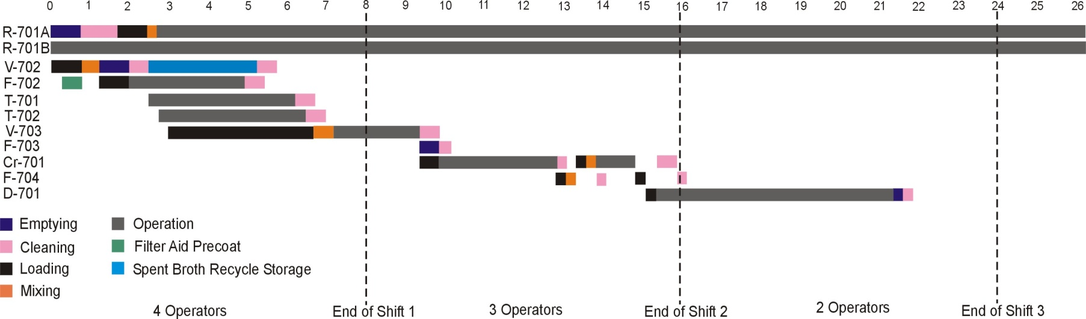

Case 3
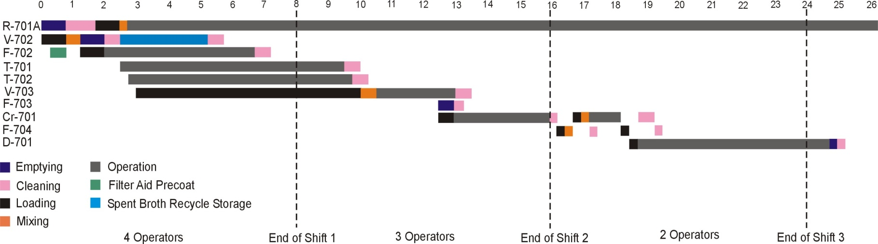
Case 4
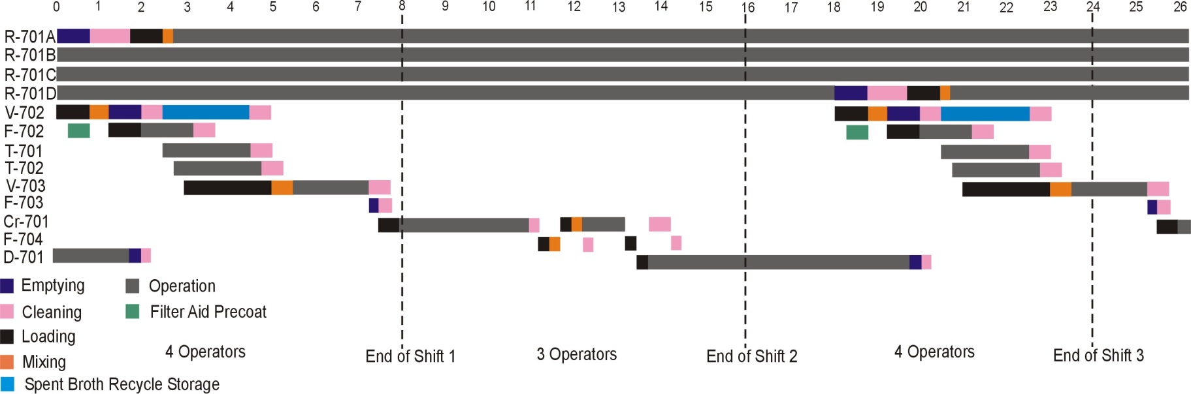

Case 5

